

**UNIVERSITY OF MALAWI**

**THE POLYTECHNIC**

**FACULTY OF APPLIED SCIENCES**

**DEPARTMENT OF COMPUTING AND INFORMATION TECHNOLOGY**

**To: Dr. P A Chikumba**

**Module: GIS-401**

**Software Requirements Specification for the Blantyre Tertiary Education Institutions (BTEI) Geographic Information System**

28th June 2019

**From**

**BIS Group 4**

Before Ndakwera [ BIS/13/PE/023]

Angella C Kamera [ BIS/14/NE/010]

Francis Ganya [ BIS/14/NE/004]

Abigail Mwale [ BIS/14/NE/026]

**Blantyre Tertiary Education Institutions GIS**

**Software Requirement Specifications**

Contents

Preface 2

1. Introduction 2

1.1 Purpose 2

1.2 Conventions 3

1.3 Glossary 3

1.4 Intended Audience and Reading Suggestions 3

1.5 Project Scope 3

1.6 References 3

2. Overall Description 4

2.1 System perspective 4

2.2 System Features 4

2.2.1 Navigation Helper (Tools) 5

2.2.2 Information Helper (Tools) 5

2.3 System Architecture 5

2.4 User Characteristics 6

2.5 Operating Environment 6

2.6 Design and Implementation Constraints 6

2.7 User Documentation 7

2.8 Assumptions and Dependencies 7

3. Specific Requirements 7

3.1 Functional Requirements 7

3.2 Non-Functional Requirements 8

3.2.1 Performance 8

3.2.2 Reliability and Availability 9

3.2.3 Usability 9

3.2.4 Security 9

4.0 System Models 9

Appendix 10

# Preface

Geographic information systems (GIS) are computer based systems which store, manipulate, analyses spatially linked data and displays summary information on a map. Such systems are composed of people, data, procedures and technology to support communication and decision making.

In Malawi, it is the current norm for students to pursue and attain an academic qualification higher than the regular Malawi School Certificate of education (MSCE). Students and parents look for information on available colleges together with relevant information on what they are offering that is: courses and approximate fees and possibly academic calendars.

Unfortunately, such information is not readily available and acquisition of such information is expensive. Potential students together with their parents incur costs to travel around to acquire this information. This is more expensive since these students want to compare available options hence they have to make travelling’s to several institutions across the city. Furthermore, acquisition of information puts an extra overhead on time which would have been used for other productive work.

# 1. Introduction

## 1.1 Purpose

The purpose of this document is to define and describe the software requirement specifications for the Blantyre TertiaryEducation Institutions geographic information system. This is the first version of the requirements document for this system.

## 1.2 Conventions

This document uses the conventions that have been outlined below and otherwise specifically stated in the document, the reader should use these conventions to understand the contents.

* Special terms and content that user should pay attention have been emphasized by bold font

## 1.3 Glossary

|  |  |
| --- | --- |
| DB | Database |
| GIS | Geographic Information System |
| BTEI GIS | Blantyre Tertiary Education Institutions GIS |
| Geo-Database | Geographic Database |
| GiB | Gigabyte |
| RAM | Random Access Memory |

## 1.4 Intended Audience and Reading Suggestions

This document is primarily intended for the **college lecturer** responsible for assessing the system prototype and generally any individual seeking to understand the system for the purpose of public use, development maintenance, testing and documentation.

* Section 2 of this document presents an overview description of the system and references.
* Section 3 discusses the specific functional requirements and non-functional requirements of the system.
* Section 4 illustrates the system models to of the system.

## 1.5 Project Scope

The BTEI GIS will be a prototype information system which will collect spatial data of tertiary education institutions and skills development institution in the city of Blantyre.

## 1.6 References

Longley, P. A., Goodchild, M. F., Maguire, D. J., & Rhind, D. W. (n.d.). *Geographical Information Systems and Science* (2nd Edition ed.).

# 2. Overall Description

This section of the document describes in brief all the general details of the system and its requirenmens.

## 2.1 System perspective

BTEI GIS will be a geographic information system that stores information of tertiary education institutions and skills development institutions in Blantyre. It will be accessible over the internet and will provide services to the public. It will store the following significant information that is needed by potential students and individuals seeking to enroll in academic and training institutions:

* **Institution location**

The system will store geo coordinates of the institution that will be used to map the institution to provide travel directions.

* **Fees details**

The system will provide approximate fees structure details for the programs that are offered by the institution.

* **Contact details**

The system will provide the institutions contact details including telephone numbers, email addresses and postal addresses.

* **Training areas**

The system will store and provide training areas which are covered by the programs that the institutions provide for instance commerce, engineering, computer science and architecture.

## 2.2 System Features

The BTEI GIS will have mainly two components. A navigation helper and an information helper.

## 2.2.1 Navigation Helper (Tools)

This system feature will allow a user to get the location of the institutions and provide directional guidance on how to reach the destination if the spatial information that will be provided will not be enough. This feature will allow the user to see important details such as distance so they can make informed decision on the optimal institution to attend.

## 2.2.2 Information Helper (Tools)

This is the main system feature that will provide information to the user. This feature will enable the user to view important details about the institutions including all the spatial attributes: contact details like phone and email, postal address, physical locations and program areas that are being offered by the institution.

## 2.3 System Architecture

The BTEI GIS will use a societal implementation and will be accessible via the internet. As such this system will use the classical client-server GIS software architecture where by the system will have hosted on a web server and clients will make request to be processed by the server. The diagram below illustrates the architecture that the BTEI GIS system will use:

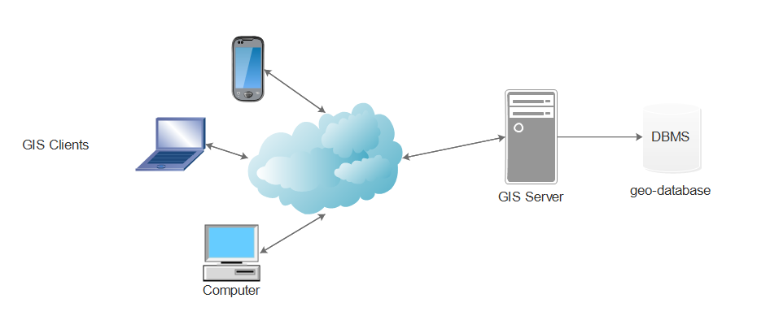

## 2.4 User Characteristics

The system is primarily developed to be used in the public domain by school leavers and individuals seeking to analyze the distribution of education institutions and skills development centers in Blantyre. Thus the system has 3 intended users

* Public citizen

This user will be able view locations and details of the institutions catered by the system. They will be able to get direction, contact details, fee structures and program areas offered.

* Geo spatial Professional

This user will be able to access everything that the standard citizen will be able to access in addition to the actual exports of the collected data

* Administrators

This user will be able to access everything including functionality to update the geo database data.

## 2.5 Operating Environment

Every system operates in a specific environment. This section outlines the environment specifications for the functional operation of the BTEI GIS Software.

The System will run in a web browser as such the client devices will only require reasonable computing resources.

See appendix for specific device requirements.

## 2.6 Design and Implementation Constraints

The BTEI GIS software will be a prototype system and has several implementation constraints

* The system will be developed by undergraduate students as such full functionality is not guaranteed due to lack of expertise.
* Resources to fully develop and deploy the system are limited as they require other financial resources currently not available.
* Programming of the system will require time which does not tally with the time frame allocated for the project.
* To be fully deployed the system will require to be reviewed by professionals which again might take time more than what is allocated for the project.

## 2.7 User Documentation

The BTEI GIS will provide the following user documentation

* Introductory Tutorials and
* User manual for maintaining the geo database

## 2.8 Assumptions and Dependencies

This sub section outlines the assumptions on which the system will operate on and its dependencies/

**Assumptions**:

* The user has basic computer skills and know how to operate a computer.
* The user has basic knowledge of geographical maps and can read basic details on a map.
* The user resides in Blantyre or intends on attending an education institution or skills development center in Blantyre.
* The user has access to a device with a compatible browser to access the system.
* The user has an active internet connection to access the system

**Dependencies**:

* The system shall utilize shape files from MASDAP to visualize the geo data on a map

# 3. Specific Requirements

This section of the document discusses the BTEI GIS system requirements in detail covering functional and non-functional requirements, system models, design constraints, assumptions, Software system attributes and other requirements.

## 3.1 Functional Requirements

User requirements gathering was conducted through the channels of observation and review. Initially similar software products were reviewed and tested as to what they offer and evaluated. Afterwards the development team observed the need for an automated Geographic information system that provides education data at the tip of their fingers. The process for information acquisition was carefully brainstormed and the following user requirements were drawn to develop a GIS that addresses the noted issues:

* The system shall allow the user to see a list of all available tertiary education institutions and skills development centers in the city of Blantyre
* The system shall allow the user to view a mapping of all the catered education institutions and skills development centers in the city of Blantyre
* The system shall allow the user to see the location and directions of how they can get to a specific catered education institution or skills development center.
* The system shall provide the user with specific contact details of a chosen education institution or skills development center catered by the system.
* The system shall allow the user to view the approximate fee amount of a chosen education institution or skills development center catered by the system
* The system shall allow user should be able to view the training areas that a chosen education institution or skills development center is offering such as commerce, computer science and engineering.

## 3.2 Non-Functional Requirements

Non-functional requirements are requirements that define the non-operational attributes of the system that have nothing to do with the system’s main functions. This sub-section of the requirements section discusses the non-functional requirements of the BTEI GIS software.

### 3.2.1 Performance

The system will be web based and for optimal performance the system must operate shall operate under the following performance constraints

* Initial program load independent of internet connection must not exceed more than a reasonable 3 minutes
* The memory requirements and processing requirements for the system must cater for low resource devices such as mobile phones

### 3.2.2 Reliability and Availability

The system shall meet the following reliability and availability constraints

* The system shall be available for users 24/7
* The system shall provide up to date information to support accurate decision making

### 3.2.3 Usability

The system shall meet the following usability requirements to enhance the user experience

* The system shall have a consistent look across all screens of the system
* The system should provide a visual direction for chosen locations
* The system shall make heavy use of graphical elements to enhance usability
* The system shall require only basic computer skills and geographical skills to use it
* The system should provide a user interface that is compatible with standard browsers such as Google Chrome, Mozilla Firefox and Microsoft Internet Explorer.

### 3.2.4 Security

The system shall conform to the following security requirements

* Access to the geo database shall only be permitted only to authorized system administrators
* System administrators will be required to provide a username and password which will conform to standard secure password requirements
* No unauthorized edits to the data in the geo database will be permitted
* User searches and system use will not be tracked without permission to enhance privacy

# 4.0 System Models

This section presents applicable system models to illustrate its functionalities. 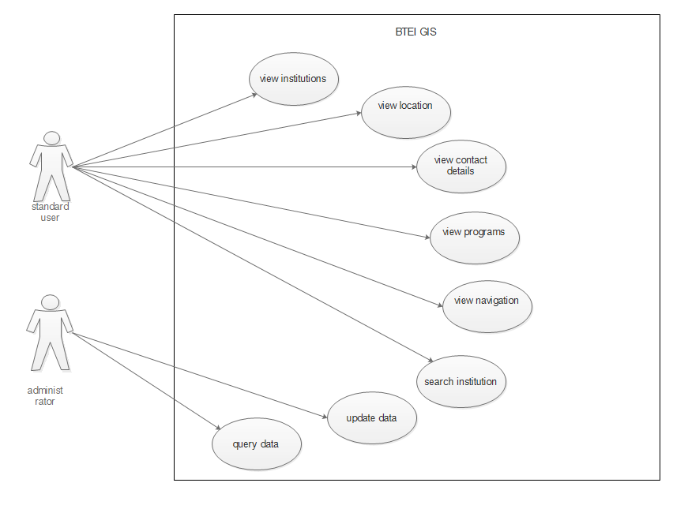

# Appendix

For optimal performance the client device should have the following specifications

|  |  |
| --- | --- |
| **Specification** | **Minimum** |
| Screen Size | 360 x 400 pixels |
| RAM | 1 GiB |
| Internet Connectivity | YES |
| Hard Drive | N/A ( user will not be required to store any local data) |

The GIS server computer will have need to have the following specifications

|  |  |
| --- | --- |
| **Specification** | **Minimum** |
| RAM | 2 GiB |
| Operating System | Linux Server OS |
| Internet Connectivity | YES |
| Hard Drive | 10 GiB |